Build Docker Image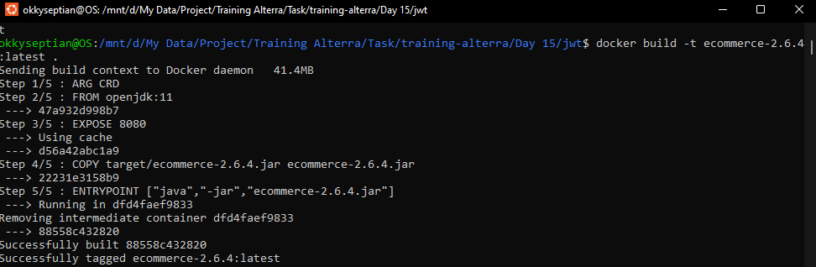

Docker Run Image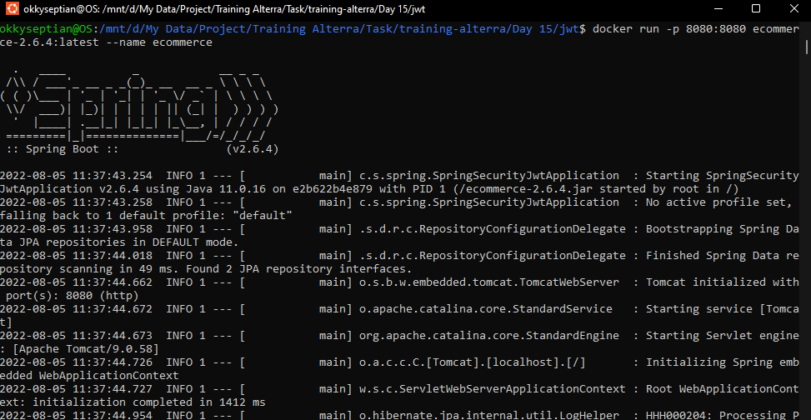

List All Docker Images